**KPI’s:**

**Total Loan Applications**

select *from Bank_loan;

select count(id) as Total_Loan_Applications from Bank_loan;

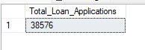

**MTD Loan Applications**

select count(id) as MTD_Total_Loan_Applications from Bank_loan

where month(issue_date) = 12 and YEAR(issue_date) = 2021;



**PMTD Loan Applications**

select count(id) as PMTD_Total_Loan_Applications from Bank_loan

where month(issue_date) = 11 and YEAR(issue_date) = 2021;

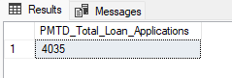

**Total Funded Amount**

select sum(loan_amount) as Total_funded_Amount from Bank_loan;



**MTD Total Funded Amount**

select sum(loan_amount) as Total_funded_Amount from Bank_loan

where MONTH(issue_date) = 12 and year(issue_date) = 2021;



**PMTD Total Funded Amount**

select sum(loan_amount) as Total_funded_Amount from Bank_loan

where MONTH(issue_date) = 11 and year(issue_date) = 2021;

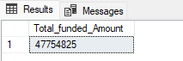

**Total Amount Received**

select sum(total_payment) as Total_Amount_Received from Bank_loan;

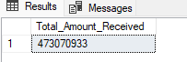

**MTD Total Amount Received**

select sum(total_payment) as MTD_Total_Amount_Received from Bank_loan

where month(issue_date) = 12 and year(issue_date)=2021;

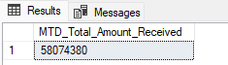

**PMTD Total Amount Received**

select sum(total_payment) as PMTD_Total_Amount_Received from Bank_loan

where month(issue_date) = 11 and year(issue_date)=2021;

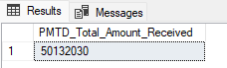

**Average Interest Rate**

select avg(int_rate)*100 as Avg_Interest from Bank_loan;

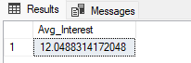

**Using Round Function for average rate:**

select round(avg(int_rate),2)*100 as Avg_Interest from Bank_loan;

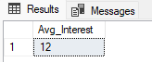

**MTD Average Interest**

select round(avg(int_rate),4)*100 as MTD_Avg_Interest from Bank_loan

where month(issue_date) = 12 and year(issue_date)=2021;

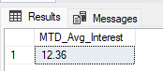

**PMTD Average Interest**

select round(avg(int_rate),4)*100 as MTD_Avg_Interest from Bank_loan

where month(issue_date) = 12 and year(issue_date)=2021;

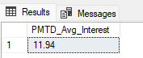

**Avg DTI**

select AVG(dti)*100 as Avg_DTI from Bank_loan;

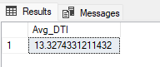

**MTD Avg DTI**

select AVG(dti)*100 as MDT_Avg_DTI from Bank_loan

where month(issue_date)=12 and year(issue_date) = 2021;

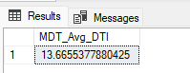

**PMTD Avg DTI**

select AVG(dti)*100 as PMDT_Avg_DTI from Bank_loan

where month(issue_date)=11 and year(issue_date) = 2021;

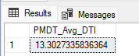

**GOOD LOAN ISSUED**

**Good Loan Percentage**

select

(count(case when loan_status = 'Fully Paid' or loan_status = 'Current' then id end)*100)

/

count(id) as Good_loan_percentage from Bank_loan;

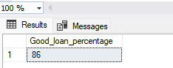

**Good Loan Applications**

select count(id) as Good_Loan_Applications from Bank_loan

where loan_status = 'Fully Paid' or loan_status='Current';

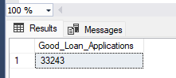

**Good Loan Funded Amount**

select sum(loan_amount) as Good_Loan_Funded_Amount from Bank_loan

where loan_status = 'Fully Paid' or loan_status='Current';

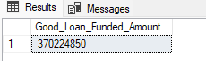

**Good Loan Amount Received**

select sum(total_payment) as Good_Loan_Received_Amount from Bank_loan

where loan_status = 'Fully Paid' or loan_status='Current';



**BAD LOAN ISSUED**

select

(count(case when loan_status = 'Charged off' then id end)*100.0)

/

count(id) as Bad_loan_percentage from Bank_loan;

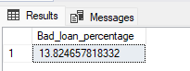

**Bad Loan Applications**

select count(id) as Bad_Loan_Applications from Bank_loan

where loan_status = 'Charged off';

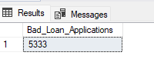

**Bad Loan Funded Amount**

select sum(loan_amount) as Bad_Loan_Funded_Amount from Bank_loan

where loan_status = 'Charged off';

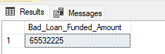

**Bad Loan Amount Received**

select sum(total_payment) as Bad_oan_Received_Amount from Bank_loan

where loan_status = 'Charged off';

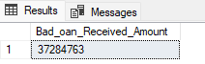

**LOAN STATUS**

SELECT

loan_status,

COUNT(id) AS Total_Loan_Applications,

SUM(total_payment) AS Total_Amount_Received,

SUM(loan_amount) AS Total_Funded_Amount,

AVG(int_rate * 100) AS Interest_Rate,

AVG(dti * 100) AS DTI

FROM

Bank_loan

GROUP BY

loan_status

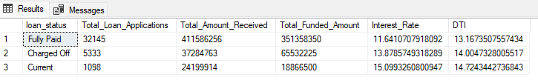

SELECT

loan_status,

SUM(total_payment) AS MTD_Total_Amount_Received,

SUM(loan_amount) AS MTD_Total_Funded_Amount

FROM

Bank_loan

where month(issue_date) =12

GROUP BY

loan_status

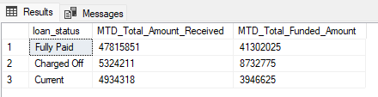

1. **BANK LOAN REPORT | OVERVIEW**

**MONTH**

SELECT

MONTH(issue_date) AS Month_Number,

DATENAME(MONTH, issue_date) AS Month_name,

COUNT(id) AS Total_Loan_Applications,

SUM(loan_amount) AS Total_Funded_Amount,

SUM(total_payment) AS Total_Amount_Received

FROM Bank_loan

GROUP BY MONTH(issue_date), DATENAME(MONTH, issue_date)

ORDER BY MONTH(issue_date)

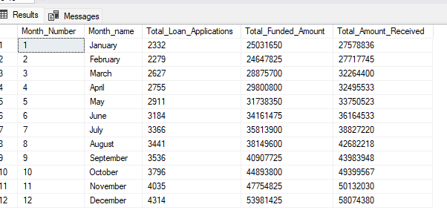

**STATE**

SELECT

address_state AS State,

COUNT(id) AS Total_Loan_Applications,

SUM(loan_amount) AS Total_Funded_Amount,

SUM(total_payment) AS Total_Amount_Received

FROM Bank_loan

GROUP BY address_state

ORDER BY count(id) desc

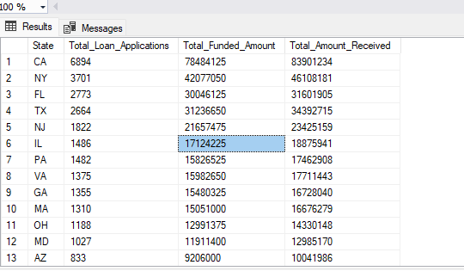

**TERM**

SELECT

term AS Term,

COUNT(id) AS Total_Loan_Applications,

SUM(loan_amount) AS Total_Funded_Amount,

SUM(total_payment) AS Total_Amount_Received

FROM Bank_loan

GROUP BY term

ORDER BY term

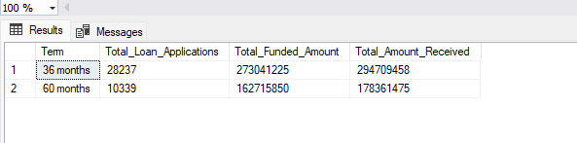

**EMPLOYEE LENGTH**

SELECT

emp_length AS Employee_Length,

COUNT(id) AS Total_Loan_Applications,

SUM(loan_amount) AS Total_Funded_Amount,

SUM(total_payment) AS Total_Amount_Received

FROM bank_loan_data

GROUP BY emp_length

ORDER BY emp_length

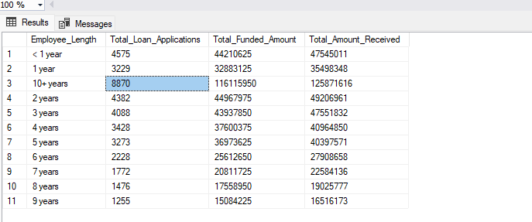

**PURPOSE**

SELECT

purpose AS PURPOSE,

COUNT(id) AS Total_Loan_Applications,

SUM(loan_amount) AS Total_Funded_Amount,

SUM(total_payment) AS Total_Amount_Received

FROM Bank_loan

GROUP BY purpose

ORDER BY purpose

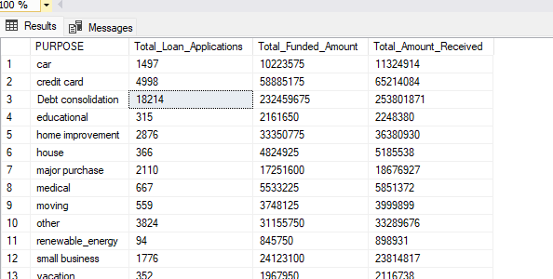

**HOME OWNERSHIP**

SELECT

home_ownership AS Home_Ownership,

COUNT(id) AS Total_Loan_Applications,

SUM(loan_amount) AS Total_Funded_Amount,

SUM(total_payment) AS Total_Amount_Received

FROM Bank_loan

GROUP BY home_ownership

ORDER BY home_ownership

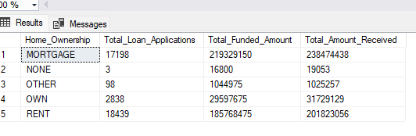

*Note: We have applied multiple Filters on all the dashboards. You can check the results for the filters as well by modifying the query and comparing the results.*

*For e.g*

*See the results when we hit the Grade A in the filters for dashboards.*

SELECT

purpose AS PURPOSE,

COUNT(id) AS Total_Loan_Applications,

SUM(loan_amount) AS Total_Funded_Amount,

SUM(total_payment) AS Total_Amount_Received

FROM Bank_loan

WHERE grade = 'A'

GROUP BY purpose

ORDER BY purpose

